# 4.2 B NETWORKS AND TREES

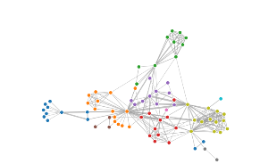1. Force Directed Graph

|  |  |
| --- | --- |
| IDIOM | Force Directed Node-Link Diagram |
| Data | Network or tree | The data consists of co-occurrence of characters in the play Les Misérables.  Nodes consists of each character. Links consists strengths between the characters. |
| Task | Explore topology, locate paths, Identifying clusters. |
| Encoding | Point marks for nodes, connecting line marks for link. |

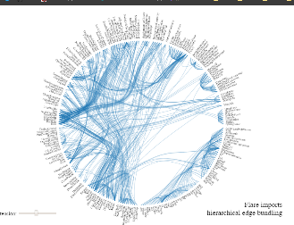2. Hierarchical Edge Bundling

|  |  |
| --- | --- |
| IDIOM | Hierarchical Edge Bundling |
| Data | Hierarchical related entities (Hierarchy between classes in a software project) |
| Task | Visualize dependencies between various classes in a software project. |
| Encoding | Tree transform to visualize node, and line mark with bundle interpolation to draw dependencies. |

**Differences between the above Idioms:**

**Force Directed Node-Link Diagram**

* Uses force to visualize strong relation.
* Visualizes topology of the network and locate paths
* The strength of force depicts the relationship strength between nodes
* Can be used to identify a group of nodes which form a cluster with a strong relationship
* Since they are based on properties of common objects like spring, more intuitive and easier to understand.
* Relatively easy to code with libraries

**Hierarchical Edge Bundling**

* Uses links between nodes to represent the relationship.
* Visualizes hierarchal relationships.
* The more connection a node has the darker/wider is the connection with other nodes.
* Can be used to find most / more connected nodes in a hierarchy
* Can be sometimes confusing some time to see connections between highly common connected nodes.
* Produces aesthetically pleasing graphs.